
Conference Registration
International Conference on Innovations in
Chemistry and Physics

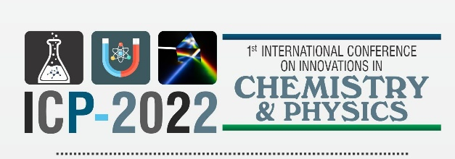

Date

Please Fill in the Registration form and Email to lcp-2022@ue.edu.pk

Host University/Institution/Company/Industry

Family Name
First Name
Participant

Mr.
Dr.

Ms.

From:

ID Card Number
Mobile No.
Email

Permanent Official Address

Did you Pay the Registration Fees? Give Transaction Details

Academics: Rs. 3000 without Boarding & Rs, 5000 with Boarding: Students: Rs. 2000 without Boarding & Rs, 3000 with Boarding

Bank Details for Registration Free
Account Title: COLLEGE GENERAL FUND UNIVERSITY OF EDUCATION
Account Number: 6510120301800048
IBAN: PK70BPUN6510120301800048
Bank Name: Bank of Punjab Branch: Samanabad, Faisalabad Branch Code: 156

Other Modes of Payment for Registration Fees

Account Title: Ghulam Muhammad Mustafa
Account Number: 03226247857

